

Assignment #3 - Final Individual Project

“Go Beyond Range: Repositioning the Toyota RAV4 PHEV for Emotional Relevance in the Electrified SUV Era”

BY MINGJUN LIU 1441230

Word count: 2638 words (excluding references)
Advanced Industry Practice – Advertising (MECM90026)
University of Melbourne | Semester 1, 2025

Executive Summary
The 2025 Toyota RAV4 PHEV arrives into a market shaped not only by electrification — but by a sense expectation. Toyota retains healthy rational equity but the brand faces a symbolic challenge of making hybrid technology personal, aspirational and culturally resonant.
The campaign repositions RAV4 not as an incremental functionalist upgrade, but a lifestyle enabler. Our strategic intuition uncovers a new era of SUV customer looking for empowered freedom: freedom to live sustainably, confidently and on their own terms.
Grounded in the Cog Model, our communication approach maps hybrid complexity toward emotional simplicity. This dual promise is encapsulated in the Big Idea—“Go Beyond Range”—which is: technical excellence that opens up emotional range. It is alive through a layered creative ecosystem telling the story of: a cinematic hero TVC, an interactive microsite and co-created shortform influencer content.
The report includes category context, consumer tensions, strategic reframing, and creative rollout that collectively reflect how RAV4 is reinventing itself in the world of the shifting automobile.
Every touchpoint delivers more RAV4 edge: from the powerful front and sleek profile to the bold available wheels. It’s more than just measurement—it’s tracking emotional resonance, movement across behaviours, and a metaphorical language shift.
With this campaign, Toyota doesn’t simply roll out a car— it redefines what the RAV4 represents in human culture: not just a hybrid that functions, but a hybrid that feels right.

Content Page
Executive Summary
1. Strategic Narrative & Cog Framework Overview 1
1.1 Introduction to Strategic Narrative 1
1.2 The Cog Model Framework 1
2. Category and Problem Analysis 2
2.1 Category Landscape: From Utility to Emotion in the Electrified SUV Era 2
2.2 Competitive Landscape: How Rivals Win with Emotion 2
2.3 Strategic Problem Statement 3
3. Consumer Understanding and Insight 4
3.1 Segmentation and Target Persona: The New SUV Mindset 4
3.2 Customer Journey Mapping: Where Emotion Fails 5
3.3 Cognitive Barrier and Cultural Challenge 5
3.4 Cognitive Driver: The Desire for Empowered Freedom 6
4. Brand & Product Understanding 6
4.1 Brand Legacy: From Rational Trust to Emotional Relevance 6
4.2 Repositioning Imperative: Emotionalise the Engineering 7
4.3 Product Story: Smart Hybrid Power, Emotionally Framed 7
5. Big Idea & Strategic Platform 8
5.1 From Insight to Idea: Reframing Freedom 8
5.2 The Big Idea 8
5.3 Strategic Platform: The Promise Framework 8
5.4 Archetype & Brand Voice 9
6. Creative Executions 9
6.1 Hero Execution: TVC – “Range of Life” 9
6.2 Hub Execution: Interactive Microsite – “What Drives You?” 10
6.3 Hygiene + Earned Execution: Influencer-led Series – “Beyond the Map” 10
6.4 Message Integration: Paid–Owned–Earned Ecosystem 11
7. Measurement & Evaluation 11
7.1 Guiding Principle: Measuring Meaning, Not Just Metrics 11
7.2 Multi-Stage Evaluation Framework 12
7.3 Evaluation Cadence: Real-Time Responsiveness 12
7.4 Cultural Impact Measurement: Language Shift as Signal 13
Reference 14

Strategic Narrative & Cog Framework Overview

1.1 Introduction to Strategic Narrative
The strategic story for the arrival of the 2025 Toyota RAV4let™ is all about one thing: taking a vehicle that was trusted and rational and turning it into a desirable and emotional SUV. Since it was first launched in 1994, RAV4 has now come to represent “Resilient, Robust, and Reliable” as well as a car that’s designed for the great-outdoors and the great-indoors, for itself and for the world on its door-step that seeks endless adventure and to take that adventure even further, and as RAV4 approaches the era of its next generation, it reflects on that role and what it might contribute to its owner’s. But given the increasing sophistication of SUV buyers – particularly in the PHEV segment – there is a clear need for a new paradigm, one of which is not only performance, but also identity, lifestyle and aspiration as well.
To make that shift emotional one, we need to get our head around and we need to influence what drives that underlying behaviour. Here is where the Cog Model is indispensable.

1.2 The Cog Model Framework
The Cog Model:
Element | Content
Problem | Emotional indistinctiveness in a saturated SUV market
Diagnosis | RAV4 is seen as rational but uninspiring
Objective | Encourage emotionally-driven PHEV consideration
Cognitive Barrier | Hybrid tech seen as complex; RAV4 perceived as functional
Challenge | Make tech feel intuitive, desirable, and identity-relevant
Driver | A desire for empowered, future-ready personal freedom
Big Idea | “Go Beyond Range”
Product Story | Smart hybrid power + intuitive tech = freedom with confidence

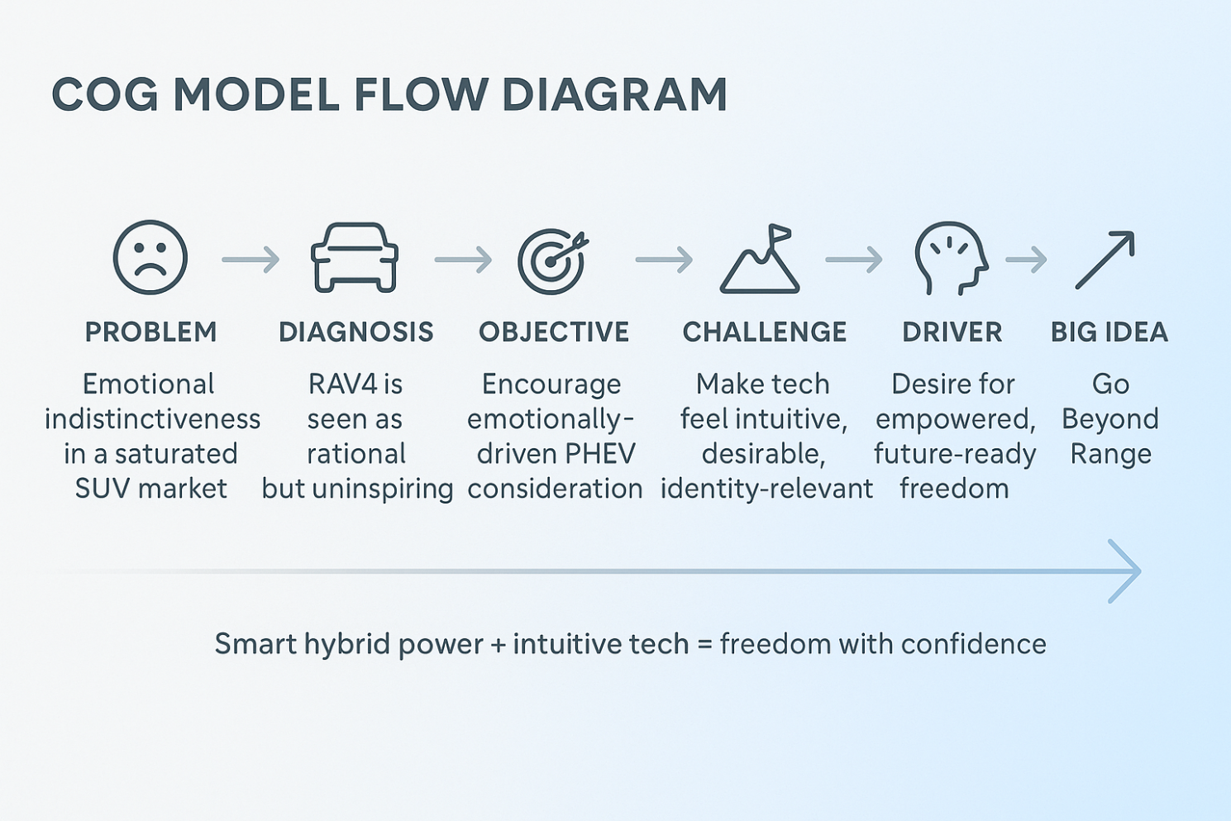

Category and Problem Analysis

2.1 Category Landscape: From Utility to Emotion in the Electrified SUV Era
The Australian SUV category is undergoing a seismic shift. Once defined by utility, performance, and functional dependability, it is now shaped by electrification, environmental consciousness, and emotional identity. While SUV sales remain dominant (Warren, 2025), what consumers seek in an SUV has changed: they now want a vehicle that not only works but means something.
In this electrified era, RAV4’s historical strengths—reliability, hybrid efficiency, and practical utility—are no longer sufficient to drive desire. As plug-in hybrid electric vehicles (PHEVs) gain regulatory and commercial traction, consumers are looking for brands that transform technical advancement into lifestyle empowerment. Function has become the entry point; emotion is now the differentiator.

Figure 1:The share of motor vehicle sales by segment, 2012 vs 2022.
Source: Author’s analysis of VFACTS annual reports.
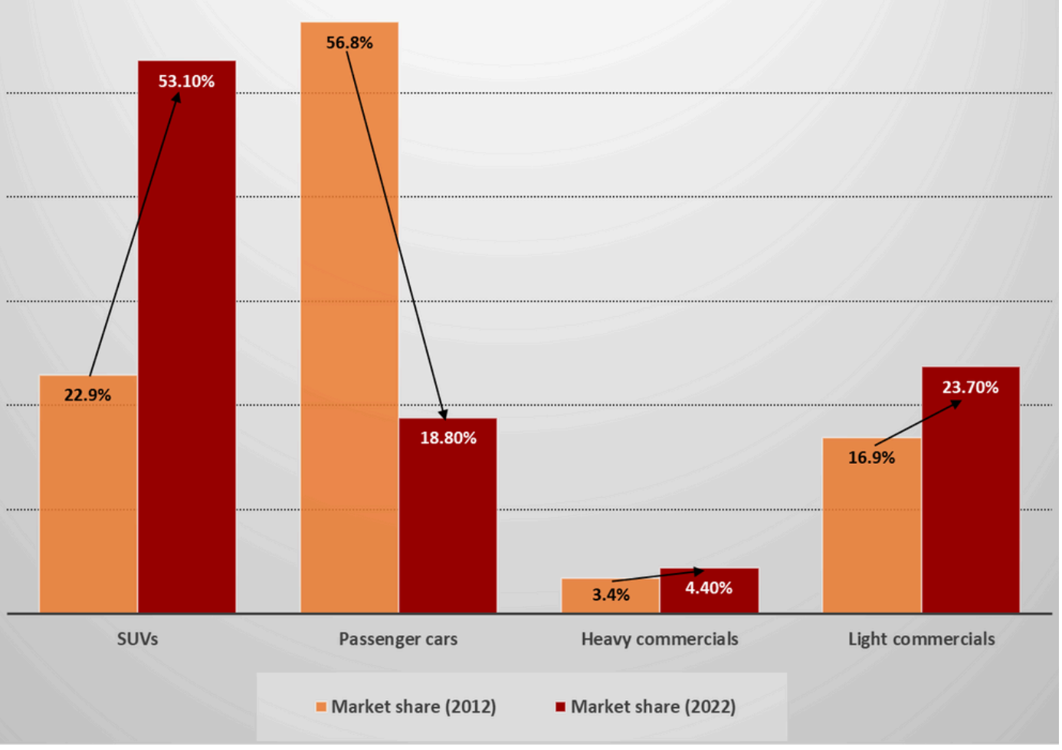
Table 1: A comparison of registered vehicle types by Australian state and territory, 2024.
Source: Author’s analysis of Australian Automobile Association data, 2024

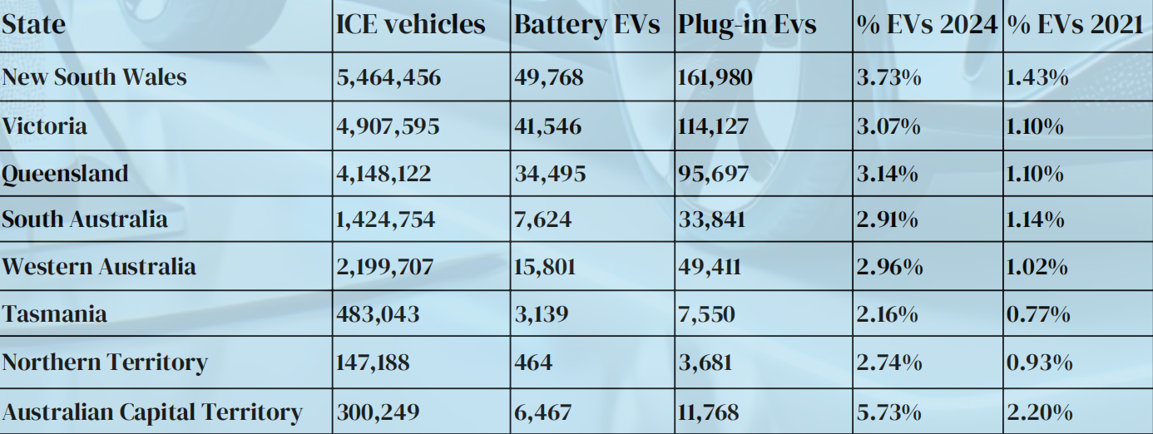

2.2 Competitive Landscape: How Rivals Win with Emotion
RAV4 faces two types of competitors, both of whom have advanced emotionally resonant storytelling:
- Traditional hybrids like the Mazda CX-5 position themselves not just through sleek design, but through the idea of “Jinba Ittai” (“horse and rider as one”)—a metaphor for harmony, control, and connection that transforms a drive into a relationship.
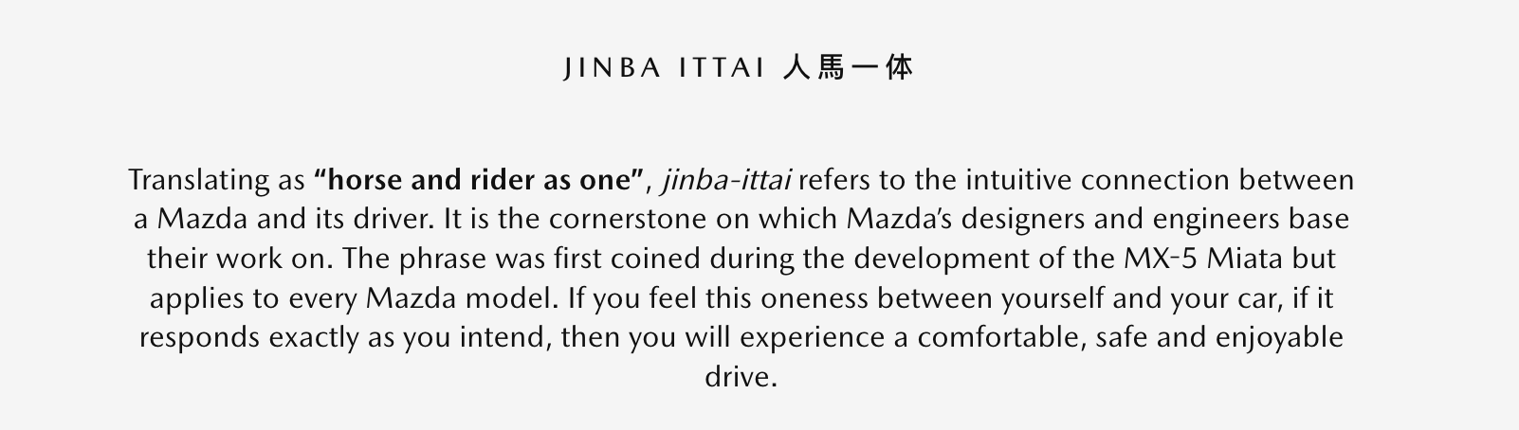
(Mazda, 2017)

- New EV disruptors such as the BYD Atto 3 build appeal through a futurist aesthetic and immersive technology, positioning the car as a gateway to tomorrow’s lifestyle. Its cabin UI and sleek dashboard are not just features, but cues of personal progress.
These brands are not simply offering alternatives—they’re telling better stories.
In contrast, RAV4, while technologically credible, lacks a culturally or emotionally engaging narrative.

2.3 Strategic Problem Statement
RAV4’s legacy as “the smart choice” worked in a rational era. Today’s SUV landscape, however, is shaped by emotion, image, and identity. Consumers want vehicles that reflect who they are—or who they aspire to become.
Thus, the central strategic problem emerges:
How can RAV4 shift from a “smart choice” to a “felt choice”?
Addressing this requires tackling four intertwined challenges:
- Elevating emotional resonance,
- Differentiating in a crowded symbolic space,
- Translating PHEV innovation into lifestyle benefits, and
- Sustaining Toyota’s leadership by redefining what leadership means in a meaning-driven category.
This category framing reveals not only where RAV4 stands, but what it must evolve into. To design a brand that emotionally connects, we must examine the emerging identity tensions and symbolic priorities shaping next-generation SUV buyers.

Consumer Understanding and Insight

3.1 Segmentation and Target Persona: The New SUV Mindset
In today’s SUV market, consumers no longer choose based purely on function—they choose based on fit: how well a car aligns with who they are and who they want to become. Based on attitudinal and lifestyle segmentation (Choo & Mokhtarian, 2002), two key groups emerge:
- Eco-Progressive Families (Sarah)
Value safety, reliability, and low emissions. They view hybrid vehicles as a responsible parenting choice. Typically research through Google, parenting blogs, and online review aggregators before test-driving via dealerships.
- Urban Explorers (Leo, Main Focus)
Sustainability-minded professionals aged 30–45 who liveing in urban area and seek independence, identity alignment, and minimal ecological footprint.
Media Behaviour Tags:
- Follow sustainability influencers on Instagram and YouTube
- Read EV forums, tech lifestyle platforms, and user-generated reviews
- Trust brands that involve consumers in narrative co-creation rather than top-down messaging

Persona Snapshot:
Attribute | Leo (Urban Explorers) | Sarah (Eco-Progressive Families)
Age | 34 | 38
Profession | Cloud Storage Operator (IT) | Primary School Teacher
Location | Inner Melbourne | Suburban Sydney
Lifestyle | - Daily commute to work- Weekend nature escapes- Values sleek tech and social consciousness | - Daily school runs- Nature-focused weekend plans- Values safety, sustainability, and practicality
Key Values | Clean technology, capability, individualism | Safety, sustainability, family-oriented responsibility
Representative Quote | "I want a car that keeps up with my life and stands for something—clean, capable, not corporate." | "I’m not looking for the flashiest car—I want something safe, smart, and responsible for my family."

3.2 Customer Journey Mapping: Where Emotion Fails
Buyer journey reveals emotional drop-offs where RAV4 fails to meet symbolic needs:
Journey Stage | Key Need | Emotional Barrier | RAV4 Gap | Key Touchpoints (P/O/E)
Awareness | Feel inspired by clean tech/stable future | Feels too rational, lacks excitement | Generic positioning | Instagram Ads (Paid),  Earned mentions
Consideration | Understand emotional & green benefits | Tech feels abstract or confusing | Little lifestyle communication | Toyota website (Owned), Reddit threads (Earned)
Purchase | Confidence in tech+identity fit | Fears mismatch with self-image | Few relatable user stories | Test-drive (Owned), YouTube vlogs (Earned)
Ownership | Share and express the brand | Not enough emotional reinforcement | Weak social advocacy/community | Instagram UGC (Earned), MyToyota App (Owned)

3.3 Cognitive Barrier and Cultural Challenge
The key cognitive barrier is that:
Consumers perceive hybrid technology as a rational upgrade, not an emotional one.
For emotionally-driven buyers like Leo, the PHEV proposition sounds “smart” but feels cold and complex. As Rajagopal (2021) notes, “When consumers perceive a product as cognitively complex, they default to avoidance or delay—especially in emotionally-loaded categories like automotive purchases.”
This is amplified by Toyota’s brand tone: safe but uninspiring, technical but unsymbolic—failing to connect with today’s identity-led car culture.

3.4 Cognitive Driver: The Desire for Empowered Freedom
Leo doesn’t just want mobility—he wants alignment. He seeks confidence, purpose, and individuality, without compromising progress or aesthetics. PHEV can offer this, but only if the brand narrates it properly.
This is not about “being green” or “owning tech,” but about living with intention—and driving a vehicle that mirrors it. RAV4 must become a badge not just of performance, but of personal evolution.
“Don’t just go farther. Go further into who you want to be.”
With this understanding, the creative platform must do more than inform—it must empower. It must reframe PHEV from a technical solution to a symbol of emotional progress. In the next section, we translate this into a brand story and product narrative that makes the leap from insight to identity.

Brand & Product Understanding

4.1 Brand Legacy: From Rational Trust to Emotional Relevance
Toyota’s brand identity has long been anchored in QDR—Quality, Durability, Reliability; also it is a leader in the practical and family car segments. Historically, RAV4 has been perceived as the “smart” choice: safe, durable, efficient. Yet in a cultural landscape where SUVs are chosen not just for capability but for symbolic alignment, this rational trust must evolve into emotional relevance.
While competitors like Mazda embody design philosophy (“Jinba Ittai”), and BYD energises the category through futuristic storytelling, RAV4 risks being “the car you end up with,” not “the car that gets you.” Consumers trust Toyota—but they don’t feel Toyota. This is the gap to close.

4.2 Repositioning Imperative: Emotionalise the Engineering
Electrification, particularly in the PHEV form, demands more than technical credibility—it requires emotional legitimacy. The new RAV4 must shift from being a machine for efficiency to a medium for meaning.
As Marc Gobé (2010) notes, emotional branding is about building shared values, not just communicating value. RAV4 must offer an experience that blends functional trust with personal aspiration—clean power, conscious living, confident control.

4.3 Product Story: Smart Hybrid Power, Emotionally Framed
The new RAV4 PHEV offers substantial upgrades:
- >95km EV range for emission-free urban living
- 2.5L AWD-e hybrid system for empowered weekend escapes
- Over-the-air multimedia system for frictionless, connected experiences
But technical features alone do not move hearts. They must be re-coded:
- EV range isn’t about fuel savings—it’s about freedom from refuelling rituals.
AWD isn’t about terrain—it’s about owning the weekend with confidence.
Multimedia UX isn’t about tech—it’s about living in sync with your environment.
It’s no longer just “what it does”—it’s “what it enables you to become.”
Core Value Proposition
“The SUV that thinks smart, feels free.”
This captures the duality of RAV4’s identity shift: from smart function to emotional freedom; from logic to lifestyle.

Big Idea & Strategic Platform

5.1 From Insight to Idea: Reframing Freedom
What we discovered was latent emotional tension: Consumers want to feel that they are in control of their lives and are aligned with progressive values — but current hybrid narratives are too rational, too dry and too far removed from personal meaning.
As Parker et al. (2021) stress that strong creative ideas are born of human truths, not product promises. What consumers are in search of isn’t just more range — they’re seeking more room to live intentionally, confidently, and freely.

5.2 The Big Idea
“Go Beyond Range”
This concept works on two layers Read:
- EV range >95km is record miles with out petrol.
- Emotional: Go beyond the mechanical, the mundane, the corporate. Live life aligned with your values.
This Big Idea relieves the tension between what consumers think they want (EV specs) and what they really want (freedom and alignment). It transforms usefulness into meaning. It repositions RAV4 from a hybrid SUV to an emotional flatbed. It’s not a question of what the car does; it’s what it enables.

5.3 Strategic Platform: The Promise Canva
Element | Strategic Content
Cause | Consumers feel trapped by sameness, complexity, and lack of emotional connection.
Effect | RAV4 PHEV offers a new kind of freedom—clean, capable, emotionally intelligent.
Promise | RAV4 lets you move through the world with power, ease, and identity alignment.
Creative Role | Turn invisible value (tech) into visible meaning (life moments).
Emotional Space | Calm confidence, future-readiness, personal agency, intuitive capability.

5.4 Archetype & Brand Voice
RAV4’s new persona pulls from two archetypes:
Explorer – Desires freedom, development and new experiences
The Caregiving Friend – Safety, Assurance, Optionality
These types don’t just establish the tone — they also help “Go Beyond Range” communicate itself across platforms and yet, emotionally, stay the same. They are also the ones who lead voice and structure of storytelling, allowing for continuity without constraint.
And now, we go beyond theory — taking “Go Beyond Range,” the brand promise, from words to life via stories, technology, and moments. The next section shows how this Big Idea scales from media to interactions to time, transforming strategy into felt experience.

Creative Executions

6.1 Hero Execution: TVC – “Range of Life”
A cinematic hero film following three symbolic paths to emotional mobility. Each persona reflects a segment need and is mapped to a product feature.
Persona | Need | Symbolic Scene
Urban Professional (Leo) | Seeks calm, tech, minimalism | Glides silently through dawn-lit streets in EV mode
Off-road Explorer | Seeks autonomy, self-trust | Powers through forest mud trails in AWD mode
Purposeful Parent (Sarah) | Seeks stable and securet | Stable and secure. Complete all household tasks  (moving, picking up children, family self-driving tours), Hero in the family
Tagline Close: “Go Beyond Range.”
Strategic Role: Drive emotional priming .and recode product features into emotionally symbolic acts.

6.2 Hub Execution: Interactive Microsite – “What Drives You?”
Format: A personalised discovery hub that maps values to vehicle features.
Features:
- Lifestyle input → suggested RAV4 configurations
- EV range simulator with real-time destination matching
- Interactive “design your journey” avatar
- New addition:
Geo-targeted ‘Book a Test Drive’ module, bridging symbolic exploration with real-world action
Strategic Role: Educate, immerse, convert. From emotional association to experiential commitment.

6.3 Hygiene + Earned Execution: “Beyond the Map”
A co-created content series with real, values-led creators who live the Big Idea.
Format:
- 45–60s YouTube Shorts / Instagram Reels
- Episodic “micro-stories” like “My unplugged weekend” or “No range anxiety—just range clarity”
Platform Rationale:
- Instagram Reels and YouTube Shorts provide high-immersion, low-friction formats ideal for emotional storytelling under 60 seconds—perfect for our personas’s content habits.
Strategic Role: Build social proof and cultural presence beyond traditional media control.

6.4 Message Integration: Paid–Owned–Earned Ecosystem
Funnel Stage | Objective | Paid | Owned | Earned
Awareness | Generate emotional salience | TVC, social teasers | Toyota AU hero page | Creator Reels, lifestyle media pickup
Consideration | Deepen alignment & meaning | Hub teaser campaign | Microsite, blog content | EV discussion forums, Reddit
Conversion | Drive test-drive action | Targeted search/display ads | Test-drive tool, dealership scheduler | Organic reviews, customer UGC
Each channel role is designed to build memory structure and reduce emotional friction at moment of decision (Sharp & Romaniuk, 2016).
These executions turn Go Beyond Range into a tangible reality. Each interaction nudges the consumer not with persuasion, but with self-recognition.
The next section details how we evaluate the campaign’s emotional, behavioural, and strategic effectiveness.

Measurement & Evaluation

7.1 Guiding Principle: Measuring Meaning, Not Just Metrics
The success of Go Beyond Range hinges not only on visibility, but on emotional imprinting and symbolic recoding. To evaluate this, we move beyond click metrics and apply a framework grounded in Ehrenberg-Bass thinking (Sharp & Romaniuk, 2016), measuring:
- Mental Availability – Are we top-of-mind at the PHEV moment?
- Emotional Coding – Do consumers feel emotionally aligned with RAV4?
- Behavioural Progression – Are digital signals translating to real-world action?

7.2 Multi-Stage Evaluation Framework
Phase | Strategic Focus | Target Outcome | Key Metrics (KPI) | Tools & Methods
Awareness | Build emotional salience | Consumers recall RAV4 in emotional SUV context | Brand recall uplift, ad view-through rate, sentiment shift | Brand tracker, YouTube analytics, social listening
Consideration | Reframe hybrid perception | Reassessment of hybrid from “rational” to “relevant” | Microsite dwell time, EV simulator completion, CTA engagement | GA4, heatmaps, UX analytics
Conversion | Inspire real-world action | Test drive intent and dealership engagement | Geo-targeted bookings, foot traffic, booking form conversion | CRM attribution, Toyota dealer data
Advocacy | Build social proof & sharing | Increase in UGC and peer-to-peer brand language | UGC volume, organic SOV, share rate of influencer content | SproutSocial, TikTok/IG scrape, creator dashboards

7.3 Evaluation Cadence: Real-Time Responsiveness
Evaluation will be conducted in fortnightly sprints during campaign rollout. This agile rhythm allows rapid testing and refinement of messaging, audience targeting, and creative tone—especially across earned and paid formats where emotional impact is most variable.
Each sprint review will be used to reweight media investment and update influencer briefs based on engagement quality and emotional trigger performance.

7.4 Cultural Impact Measurement: Language Shift as Signal
To assess whether Go Beyond Range is creating cultural and symbolic change, we track the evolution of user language:
- “This will be monitored through qualitative social scraping and NLP-based analysis of RAV4-related conversations across Reddit, product forums, and YouTube comments—measuring shifts in emotional descriptors (e.g., from ‘efficient’ to ‘empowering’, or ‘safe’ to ‘self-defining’).”
This data provides qualitative proof of brand re-coding—evidence that RAV4 is not just understood, but internalised and expressed. When consumers begin describing RAV4 with emotionally elevated language then the campaign has achieved more than reach. It has shifted brand meaning. We will know we’ve succeeded when drivers no longer say “it saves fuel”—but “it feels like me.”

Reference
Carlisi, G. (2019, April 4). Competitive Landscape - Strategic Passenger Vehicles Architectures Benchmark. Webthesis.biblio.polito.it. https://webthesis.biblio.polito.it/10713/
Choo, S., & Mokhtarian, P. L. (2002). The Relationship of Vehicle Type Choice to Personality, Lifestyle, Attitudinal, and Demographic Variables. Escholarship.org. https://escholarship.org/uc/item/6gx9v8r6
Egbue, O., & Long, S. (2012). Barriers to widespread adoption of electric vehicles: An analysis of consumer attitudes and perceptions. Energy Policy, 48, 717–729. https://doi.org/10.1016/j.enpol.2012.06.009
Escalas, J. E. (2004). Narrative Processing: Building Consumer Connections to Brands. Journal of Consumer Psychology, 14(1-2), 168–180. https://doi.org/10.1207/s15327663jcp1401&2_19
Fan, X. (2022). Navigating the German EV Market: Strategies for BYD’s Sales Growth. CBS Research Portal. https://research.cbs.dk/en/studentProjects/navigating-the-german-ev-market-strategies-for-byds-sales-growth
Gobe, M. (2025). Emotional Branding. Google Books. https://books.google.com.au/books?hl=en&lr=&id=fmmCDwAAQBAJ&redir_esc=y
Hafeez, K. (2025). Chapter 9: IMC Frameworks and Models: Aligning Messaging Across Channels.
Houghton, D. M. (2021). Story elements, narrative transportation, and schema incongruity: a framework for enhancing brand storytelling effectiveness. Journal of Strategic Marketing, 31(7), 1–16. https://doi.org/10.1080/0965254x.2021.1916570
Mazda. (2017). Mazda Dictionary | Jinba Ittai | Mazda UK. Mazda.co.uk. https://www.mazda.co.uk/why-mazda/mazda-stories/mazda-dictionary/
Nykänen, A. (2019). Go-To-Market Strategy for New Medical Device. Theseus.fi. http://www.theseus.fi/handle/10024/161777
Padgett, D., & Allen, D. (1997). Communicating Experiences: A Narrative Approach to Creating Service Brand Image. Journal of Advertising, 26(4), 49–62. https://doi.org/10.1080/00913367.1997.10673535
Parker, J., Koslow, S., Ang, L., & Tevi, A. (2020). How Does Consumer Insight Support The Leap to a Creative Idea? Journal of Advertising Research, 61(1), 30–43. https://doi.org/10.2501/jar-2020-012
Rajagopal. (2021). Consumer Behavior and Cognitive Theories. Crowd-Based Business Models, 197–225. https://doi.org/10.1007/978-3-030-77083-9_7
Rezvani, Z., Jansson, J., & Bodin, J. (2015). Advances in Consumer Electric Vehicle Adoption Research: A Review and Research Agenda. Transportation Research Part D: Transport and Environment, 34(1), 122–136. https://doi.org/10.1016/j.trd.2014.10.010
Sharp, B. (2010). How Brands Grow: What Marketers Don’t Know. Oxford University Press.
Thompson, C. J., Rindfleisch, A., & Arsel, Z. (2006). Emotional Branding and the Strategic Value of the Doppelgänger Brand Image. Journal of Marketing, 70(1), 50–64. https://doi.org/10.1509/jmkg.70.1.050.qxd
Toyota Australia. (2025). All-New, Sixth-Generation Toyota RAV4 Makes Global Debut | Latest News. New Cars Toyota Australia: Prices, Service Centres, Dealers, Test Drives. https://www.toyota.com.au/news/all-new-sixth-generation-toyota-rav4-makes-global-debut
Troidl, A. D. (2016). Consumer Valuation of Fuel Economy in the Australian Automobile Market. Clemson OPEN. https://open.clemson.edu/all_theses/2436/
Warren, A. (2025). Shifting Gears: An Economic Geography Analysis of Australia’s Downstream Automotive Sector. Figshare. https://doi.org/10.71747/uow-r3gk326m.28455650.v1

AI content
1. The Lifeworld and Subjective Meaning-Making
l Habermas’s (1981) lifeworld theory frames communication as embedded within shared cultural horizons and assumptions. In digital contexts, the lifeworld is increasingly mediated, with platforms like X shaping the background through which users interpret credibility, risk, and community. Morimoto and Friedland (2010) argue that politically engaged users do not simply consume media—they live through it. In this affective and mediated lifeworld, fear shapes how users interpret not only content, but the contours of reality itself.

Misinformation, under this lens, is not evaluated solely by facticity but by coherence with emotional and communal logics. As such, content perceived externally as false may still “make sense” when situated within the emotional grammar of a lifeworld structured by fear.

2. Social Identity, Emotion, and Group Solidarity
l Social Identity Theory (Tajfel & Turner, 1979) explains how individuals form part of their self-concept from group affiliation. In digital communities, emotional expressions such as fear reinforce in-group cohesion and sharpen boundaries against perceived out-groups. Within MAGA-affiliated circles, fear-driven narratives—on election fraud or border insecurity—are not only persuasive but identity-affirming.
Marwick and Lewis (2017) show that misinformation persists not because of factual accuracy, but because it “feels true” within emotionally bonded collectives. This “emotional truth effect” is magnified where trust in institutions is low and symbolic belonging is high—conditions typical of polarised online publics.

3. Uses and Gratifications: Emotional Needs and Media Practice
l While early U&G research emphasised informational or entertainment motives, contemporary approaches recognise emotion as a core driver of media use. Sundar and Limperos (2013) highlight how digital affordances enable affective gratifications, while Perks and Turner (2019) observe that users often seek content that offers emotional stimulation, relief, or validation. For MAGA users like Daniel, fear-laden content may function not only as political commentary, but as an emotionally meaningful tool for community-building, vigilance, and expressive resistance.

Together, these frameworks demonstrate that misinformation is not merely a matter of distorted facts or ideological manipulation—it must be understood within the affective and social environments that give it meaning. Despite growing literature on either emotion or misinformation, few studies critically examine how fear operates as a lived, emotionally structured logic within politicised digital lifeworlds. This research directly addresses that gap, investigating how one MAGA-aligned user experiences, interprets, and circulates fear as a meaningful—if contested—response to perceived crisis.

Methodology
This study adopts a qualitative, interpretive approach to examine how fear shapes misinformation sharing within MAGA communities on X (formerly Twitter). Rather than pursuing generalisable claims or causal explanations, it seeks to uncover the subjective logic, affective motivations, and meaning-making processes embedded in one user’s digitally mediated lifeworld.
The research is grounded in Lifeworld theory (Habermas, 1981), which conceptualises everyday communication as structured by shared cultural assumptions and emotional orientations. In a platform-saturated media landscape, environments like X do more than deliver information—they shape emotional perception, identity boundaries, and moral urgency. This framework is supported by Papacharissi’s (2015) Affective Publics, which explains how emotions mobilise digital publics; Social Identity Theory (Tajfel & Turner, 1979), which reveals how in-group cohesion is emotionally maintained; and Uses and Gratifications theory (Sundar & Limperos, 2013), which offers insight into affect-driven media engagement.
Data were collected through a semi-structured, in-depth interview (n=1) with a purposively selected participant: a 25-year-old U.S. postgraduate student, politically conservative, and an active user embedded in MAGA-aligned X communities. The interview was conducted via Zoom in 25th May 2025 and lasted approximately 45 minutes. This format allowed both thematic consistency and flexibility to follow the participant’s narrative, particularly around emotional responses, misinformation beliefs, and sharing practices.
Guided by a hermeneutic framework, the interview was transcribed verbatim and analysed using a three-level interpretive strategy: (1) general experience and affective logic, (2) linguistic and narrative nuances, and (3) emergent subjective themes. As Kvale and Brinkmann (2009) argue, qualitative interviews are uniquely suited to uncover how individuals assign meaning to complex emotional realities, especially within politicised media environments.
This single-case design does not aim for statistical representativeness, but rather for depth and contextual richness. Ethical approval was obtained, and informed consent was secured from the participant, whose identity has been anonymised in all materials and transcripts.
Interpretation
Level 1: Overall Experience and Practice
At a broader level, Daniel’s engagement with X (formerly Twitter) exemplifies a deeply affective mode of media use, where fear operates not as a disabling emotion but as a structuring force for perception, action, and group identity. Drawing on Habermas’s concept of the lifeworld, X functions in Daniel’s everyday life not merely as a tool for communication, but as a social and symbolic environment where meaning is continually produced and re-affirmed.
Daniel recalls joining X during the 2016 U.S. election, attracted by its immediacy and perceived authenticity: “finally, here’s a place where the truth isn’t being twisted.” This language highlights his dissatisfaction with institutional media and suggests that X offers something more emotionally resonant—what Uses and Gratifications theory would call “affective utility.” He does not seek objective information alone; he seeks a space where emotional validation, group solidarity, and ideological clarity are available and reinforced.
His everyday interaction with X centers on topics like election integrity, border control, and freedom of speech. But these are not treated as mere policy concerns—they are imbued with existential weight. He describes the platform as “a frontline in a battle for the country’s soul,” revealing a perception of participation that is urgent, moral, and emotional. This framing reflects Papacharissi’s theory of affective publics: Daniel and his MAGA peers form a network not around shared facts, but around shared affect—especially fear, urgency, and moral threat.
Notably, Daniel does not describe fear as incapacitating. On the contrary, he says, “that fear doesn’t freeze me—it sharpens me.” Emotion, in his lifeworld, is not irrational—it is clarifying. It legitimizes attention, reinforces group coherence, and justifies action. His evaluative framework prioritizes “internal logic” and community alignment over institutional credibility: “Believability… is about whether it reflects what the people I trust are also seeing.” This view exemplifies a kind of epistemic collectivism, where truth is emotionally and socially co-produced within a like-minded network—closely aligned with Social Identity Theory.
The affective atmosphere of X is crucial to this process. Daniel describes the tone as “intense—angry, frustrated, and sometimes fearful,” yet he embraces this intensity. Rather than labeling it toxic, he frames it as evidence of genuine civic alertness: “It’s like we’re all trying to sound the alarm.” The emotional saturation of the platform is not a side effect but a feature—it confirms the seriousness of the moment and sustains his sense of being part of a vigilant public.
Crucially, even misinformation is reframed through this affective logic. Daniel notes, “when something gets fact-checked… that actually raises my interest.” In his view, suppression by institutional sources acts as a signal of deeper, concealed truths. This epistemic reversal resonates with Morimoto and Friedland’s (2010) notion of a fragmented lifeworld shaped by distrust in dominant systems, where individuals navigate meaning through emotional resonance and peer affirmation.
Daniel’s engagement with X, then, is not just driven by content—it is structured by emotional dynamics embedded in his lifeworld. Fear, for him, is not a passing feeling but a lens through which reality is interpreted and action is compelled. X becomes both mirror and amplifier: it reflects his fears, while also intensifying them into a logic of participation, sharing, and vigilance.
In sum, Daniel’s media use is existential in that it fulfills core emotional and identity needs. It provides not only information but orientation, not just opinions but a sense of purpose. Through emotionally-driven participation on X, Daniel affirms his role within a broader struggle—not only to reveal “the truth,” but to protect what he perceives as the essence of America itself. This affective attachment renders X more than a digital platform—it becomes a site of emotional home-making and symbolic defense.
Level 2: Nuances of Practice
A close reading of Daniel’s language reveals a discursive world built on emotionally saturated metaphors that sustain a lived experience of vigilance and moral duty. His repeated use of phrases like “wake up,” “the ground is shifting,” “battle for the country’s soul,” and “stay alert” transforms political life into a state of constant alarm. X is described not as a platform, but as a “frontline”—a metaphor that positions Daniel as an active combatant in a symbolic war. This aligns with Papacharissi’s notion of affective publics, wherein publics coalesce through emotional urgency rather than rational deliberation.
These metaphors function beyond expression—they shape epistemology. When Daniel says, “if something gets fact-checked… that actually raises my interest,” he reframes suppression as validation. In his interpretive logic, emotional resonance and community affirmation override empirical verification. This inversion of epistemic trust suggests a lifeworld where “truth” is not institutionally defined but emotionally confirmed—a notion that mirrors Morimoto and Friedland’s insights on media sense-making in uncertain environments.
Another discursive pattern is his frequent invocation of “they”—a shadowy antagonist who “doesn’t want you to see this” or is “eroding our rights.” This externalized threat constructs clear symbolic boundaries between an in-group of truth-tellers and an out-group of suppressors. Consistent with Social Identity Theory, this boundary-making fosters belonging and purpose. Fear here is both a diagnostic and a mobilizing force.
Daniel’s sharing practices also embody an emotionally strategic intent. He reposts content to “jolt” viewers, to make them “stop scrolling” and confront uncomfortable realities. As Uses and Gratifications theory suggests, emotional intensity—not factuality—is often the core driver of engagement. Daniel’s aim is affective disruption, not persuasion.
Lastly, emotional expressions like “validation,” “confirmation,” and “resonance” suggest a lifeworld where trust is communally negotiated. Truth emerges not from institutional credibility but from shared emotional logic. What appears as misinformation to outsiders is, within this affective lifeworld, an emotionally coherent and morally urgent message.
Level 3: Subjective Theme Based on Subjective Experience
At the core of Daniel’s narrative lies a defining subjective theme: fear as a moral imperative. Unlike typical portrayals of fear as destabilizing or irrational, Daniel positions it as ethically necessary—a signal of awareness, urgency, and civic responsibility. When he says, “Fear doesn’t freeze me—it sharpens me,” he expresses not vulnerability, but a belief that fear is a clarifying force that reveals hidden dangers and compels action.
Within this lifeworld, fear operates not as emotional noise, but as moral signal. Daniel views his emotional reactions as evidence of heightened perception, not weakness. His insistence on “waking people up” and “breaking the spell of complacency” positions him as an emotional intermediary—someone who converts affect into awareness. In this framework, fear becomes a tool of civic pedagogy: by sharing content that unsettles or alarms, Daniel believes he helps others “see more clearly.” This transforms emotion into action, and sharing into moral instruction.
This emotional logic also resists dominant narratives around misinformation. Daniel explicitly rejects the idea that fear-induced sharing reflects gullibility. Instead, he frames it as principled defiance: “Sometimes fear isn’t dysfunction. Sometimes it’s a sign that people are finally waking up.” In this reversal, fear becomes evidence of integrity, not manipulation—a marker of those who are emotionally attuned to political decay. Here, affect becomes epistemic authority.
Further, Daniel’s mistrust of institutional verification underscores a shift from procedural truth to affective coherence. What matters is not whether something is officially verified, but whether it “feels real,” whether it aligns with his lived sense of betrayal and loss. Emotion becomes a diagnostic tool—a way of detecting what official narratives suppress. As such, misinformation, within his lifeworld, is reclassified as emotionally truthful even when factually contested.
In sum, Daniel’s emotional worldview is not passive—it is strategic, pedagogical, and collectivist. Fear is not just felt, but deployed—as a mechanism of community bonding, moral alarm, and digital resistance. His actions on X are thus not simply expressive, but performative: they constitute a lifeworld in which emotion is political, misinformation is recontextualized, and fear becomes a shared grammar of meaning and belonging.
Conclusion
This research investigated how fear—as both an affective experience and a social mechanism—shapes the sharing of misinformation within MAGA communities on X. Drawing on Lifeworld theory and a qualitative case study, it revealed how digital environments saturated with emotion mediate users’ perceptions of truth, group identity, and civic responsibility.
Rather than paralyzing, fear was experienced by the participant as emotionally clarifying. It served as both an internal response to perceived political decay and an externalised moral imperative to alert others. Within this framework, misinformation was not judged by conventional standards of factuality, but by its alignment with an affective logic: whether it resonated with lived experience, confirmed group values, and mobilised action. Sharing such content became a performative act of care, solidarity, and symbolic resistance.
These insights underscore the relevance of Lifeworld theory in understanding digitally mediated meaning-making, where truth is not merely processed cognitively but constructed emotionally. They also reinforce Papacharissi’s (2015) concept of affective publics, in which emotion structures not just expression but political belonging. Together, these frameworks challenge rationalist misinformation models that isolate belief from the affective and social contexts in which it circulates.
Though limited to a single respondent, the study provides a thick description of how political emotions like fear function as epistemic and mobilising tools in digital culture. It opens space for future research to compare how other ideological groups emotionally legitimise contested narratives in similarly networked lifeworlds.
Ultimately, confronting the misinformation crisis requires more than content correction—it demands an engagement with the affective infrastructures that sustain emotional truths. Fear, far from being a distraction from reason, may be the very terrain on which belief and participation are formed in contemporary digital publics.

